1.  Pure water: dams, wells, oceans, rivers, lakes, rain…  2.  3. Wastewater and treatments  - Physicochemical Methods  - Biotechnology Methods (Non Conventional) | “MODERN BIOTECHNOLOGICAL METHODS IN WASTEWATER TREATMENT”  4. BIOLOGICAL WASTEWATER TREATMENT SYSTEMS The bio adsorption technology, The membrane biofilm reactor, Bioelectrochemical systems (BES), The microbial fuel cells are some of excited and modern technologies used.  4.1. THE MEMBRANE BIOFILM REACTORS Sequential batch biofilm reactor (SBBR), Moving bed biofilm reactor (MBBR), The micro porous membrane bioreactor (MBR), 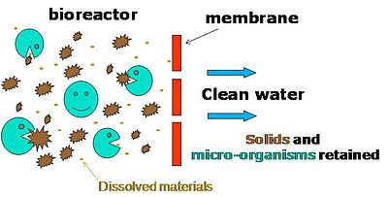ASSESSMENT These bioreactors have much merits but some limits like the Restricted to low capacities, high cost, Entrainment loss of particle-biofilm aggregates, must be reviewed 4.2. BIOELECTROCHEMICAL SYSTEMS (BES) is integration of electrodes within the biological reactors to regain resources present in the wastewater  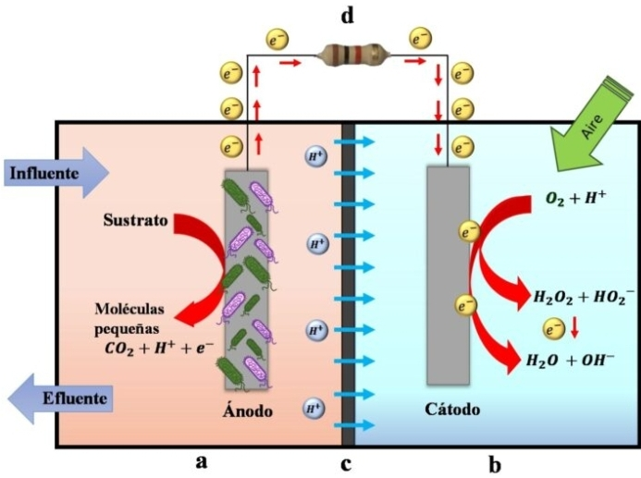 | MECHANISMS: trapping electrical power ahead from organic pollutants in microbial fuel cells, collecting the additional products like CH2, H2, high standard water in microbial electrosynthesis cells, and pulling out particular contaminants as perchlorate, heavy metal etc. ASSESSMENT: the improvement of the current processes performance, The conversion of CO₂ to methane, Stabilizing the biological process, Reducing the high costs 4.3 BIO-ADSORPTION The bio adsorption process occurs by interactions between the metal and specific active sites (carboxyl, amino, sulfate groups, among others), present in the coatings of the biomaterial. The ion-exchange is the main mechanism within a bioreactor.  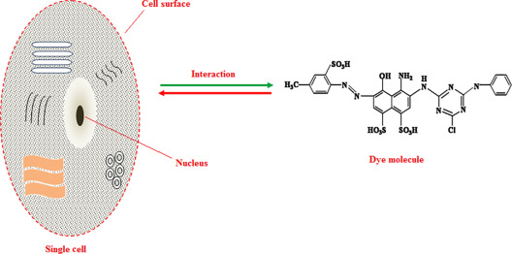  ASSESSMENT : technology remains expensive, moreover adsorption and desorption capability as well as reusability, all of which are based on the chemical and physical structures of bio-adsorbents which affect the industrial-scale  CONCLUSION There is not any universal method yet that could be used to eliminate all contaminants from wastewater, hence biotechnological as well as conventional technologies involved in water treatment must be secured by the installation of continuous analyzers which ensure that the desired water quality is respected at all times.  By Charles Lwamba

