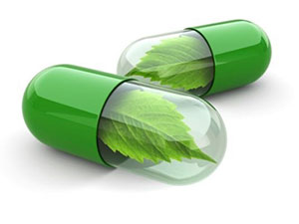  People around the world are looking for more natural alternatives to treat health conditions or problems and in turn prevent diseases of all kinds.  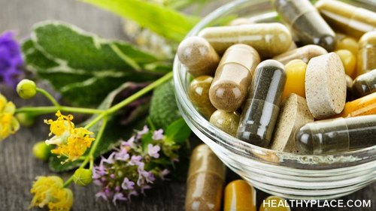  An herb or botanical product is a plant or part of a plant that people use to try to stay healthy or to treat diseases and health conditions and therefore an herbal product or supplement is a type of dietary supplement that contains one or more herbs.  Example  Chinese herbal medicines are widely used as immuno-modulators. Herbal products come in many different forms and can be used internally or externally. | IMPACT OF HERBAL SUPPLEMENTS NOWADAYS  Herbs and associated extracts are major components of complementary and alternative medicines used in the United States and worldwide.  And herbal product forms include:  - liquid extracts, teas,  - tablets and capsules,  - bath salts, oils,  - ointments.  PHARMACOKINETIC AND PHARMACODYNAMICS INTERACTIONS  Risk of a pharmacodynamics interaction occurs when an herbal supplement has a direct effect on the mechanism of action of a coadministered drug.  Direct pharmacologic effects of an herbal supplement may antagonize or exacerbate the drug's clinical effects without changing the drug's concentration. | “Food and Drug Administration” (FDA) AND HERBAL SUPPLEMENTS  FDA considers herbal supplements to be foods and not drugs for this reason they are not subject to the same regulations, testing standards, manufacturing and labeling as drugs  According to the FDA, "dietary supplements are not intended to treat , diagnose, cure, or alleviate the effects of diseases ”.  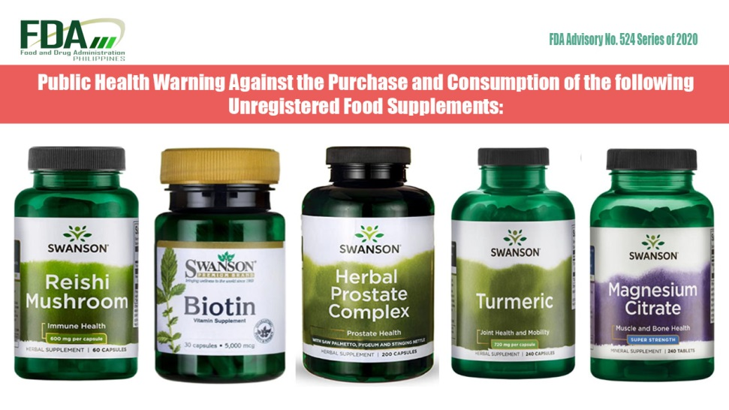  CONCLUSION  Many people believe that products labeled "natural" are always safe and good for them, this is not necessarily true. Medicinal herbs do not go through the same control and testing as conventional medicines. For this reason, care must be taken and take into account the supplement that is going to be used or ingested  By: Lizet Ramirez

